МИНИСТЕРСТВО ОБРАЗОВАНИЯ И НАУКИ РОССИЙСКОЙ ФЕДЕРАЦИИ

Федеральное государственное автономное образовательное учреждение высшего образования   
**«Национальный исследовательский   
Нижегородский государственный университет им. Н.И. Лобачевского»**

**(ННГУ)**

**Институт информационных технологий, математики и механики**

**Кафедра программной инженерии**

Направление подготовки:

«Фундаментальная информатика и информационные технологии»

**ОТЧЕТ**

По индивидуальному Практическому заданию:

**«Калькулятор»**

**Выполнила:** студентка группы 381606-2

Колосова Евгения Александровна

**Научный руководитель:** Доцент кафедры программной инженерии

Борисов Николай Анатольевич

Нижний Новгород  
2019

Введение

В этой лабораторной работе поднята задача по созданию собственного калькулятора в мобильных приложениях с Sailfish OS.

Целью работы является приобретение основных навыков создания нативного пользовательского QML-интерфейса с полноценным функционалом. Требуется получить в итоге корректную работы программы. Следует выполнить все этапы из постановки задачи этой лабораторной работы.

Постановка задачи

Основной задачей являлось создание кастомного калькулятора, который будет отвечать всем стандартам калькуляторов, уже реализованных на других платформах и внедренных в мобильные телефоны и смартфоны на текущий момент. Также весь основной функционал должен иметь безошибочную точность, присущую уже реализованным и внедренным в стабильное ПО калькуляторам.

В приложении идет работа с .js файлом, который содержит основную функциональную нагрузку и обычные .qml файлы, в которых этот функционал «прикручен» к пользовательскому интерфейсу.

Внешний вид приложения и поэтапные вехи его работы:

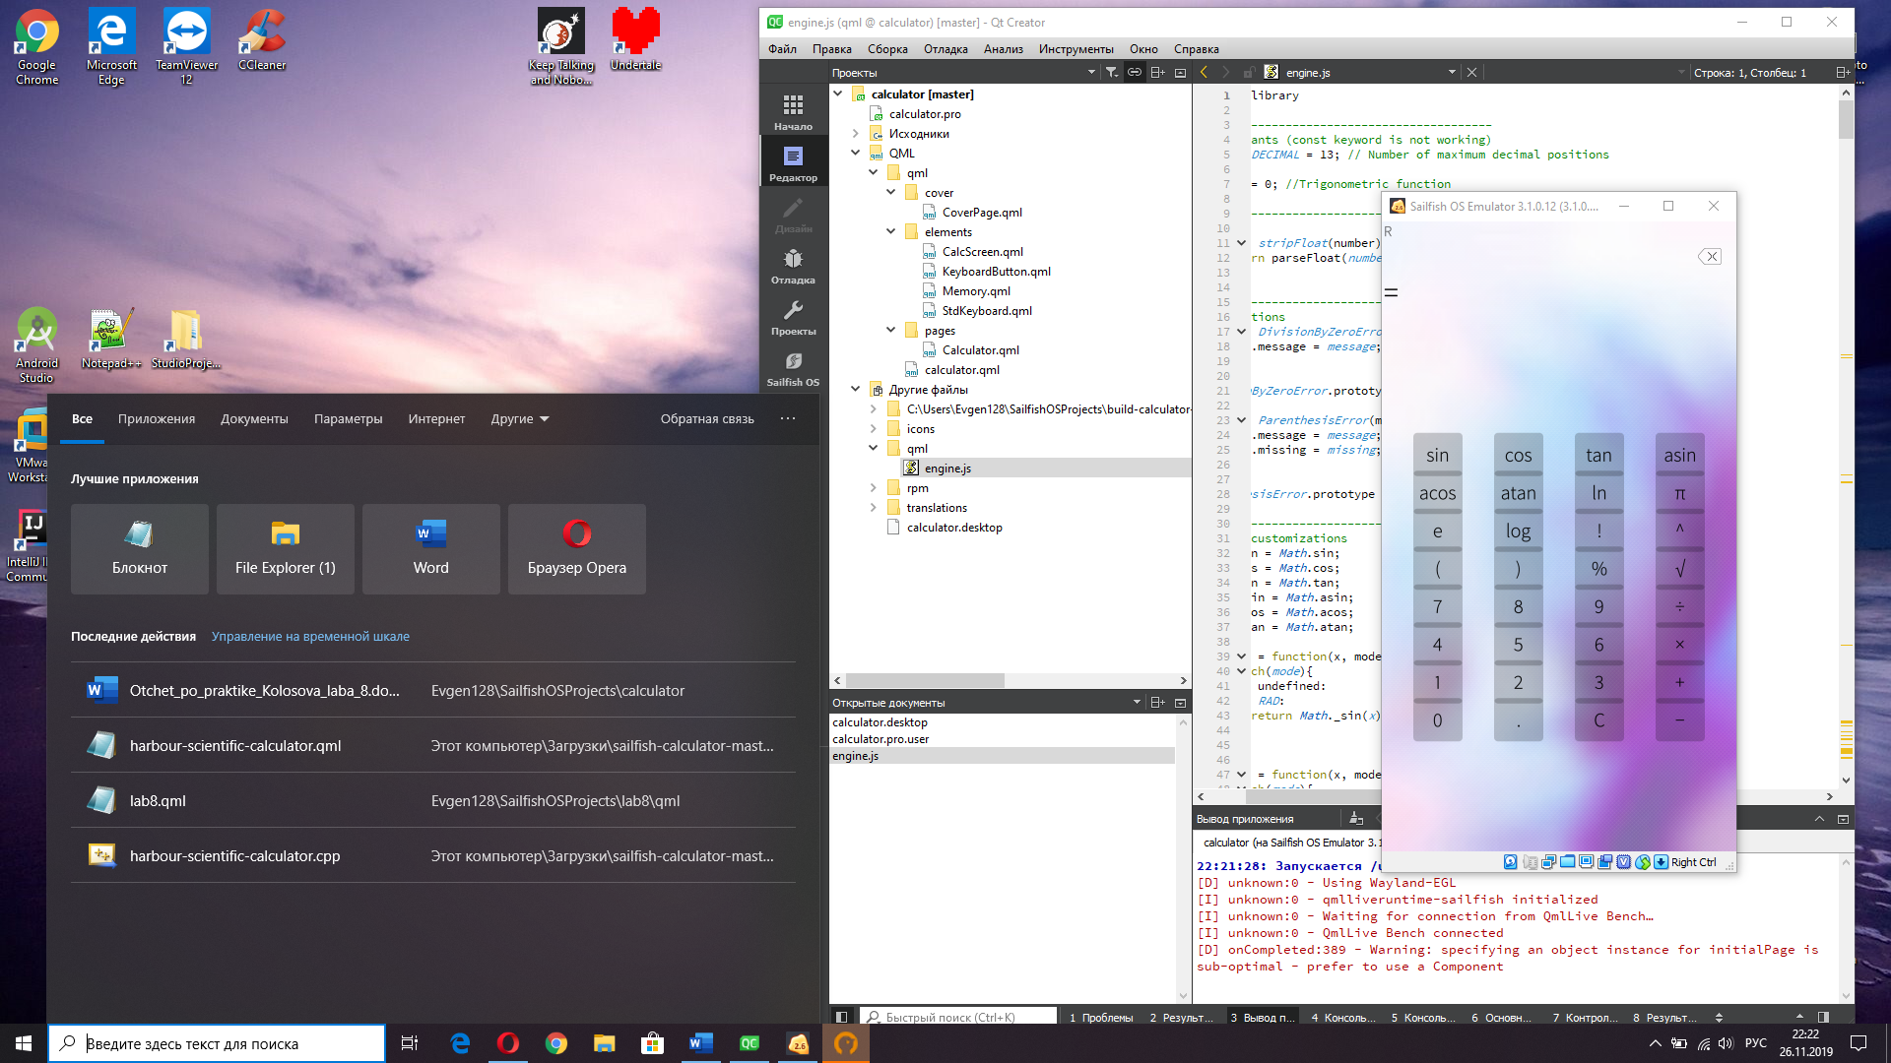

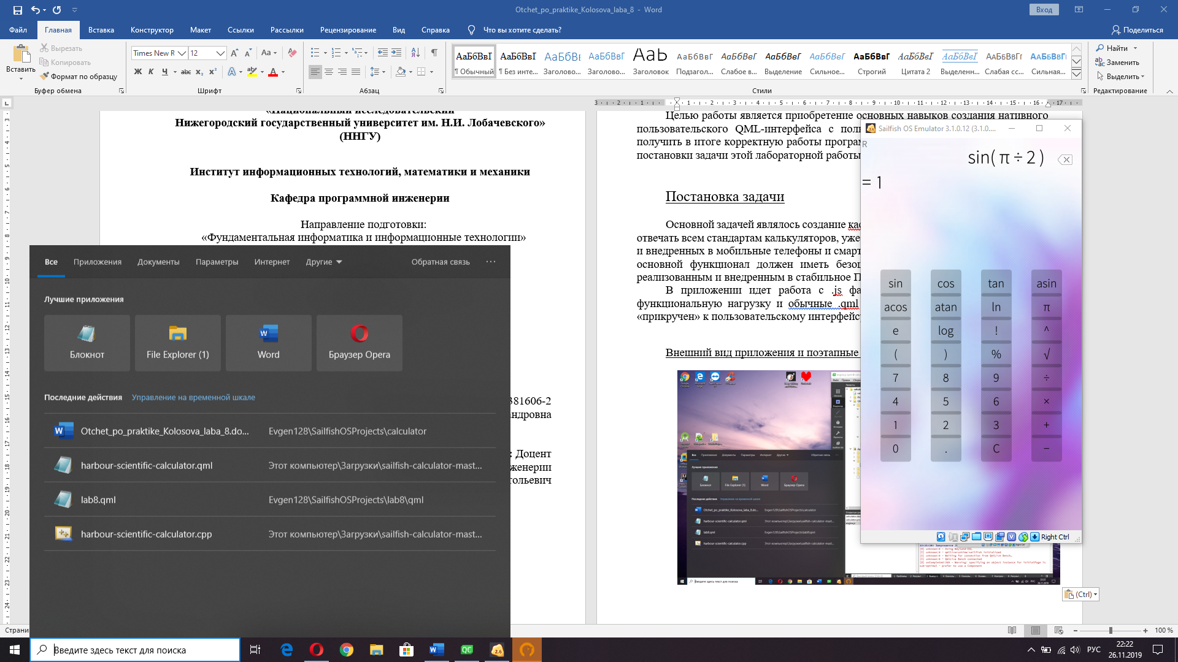 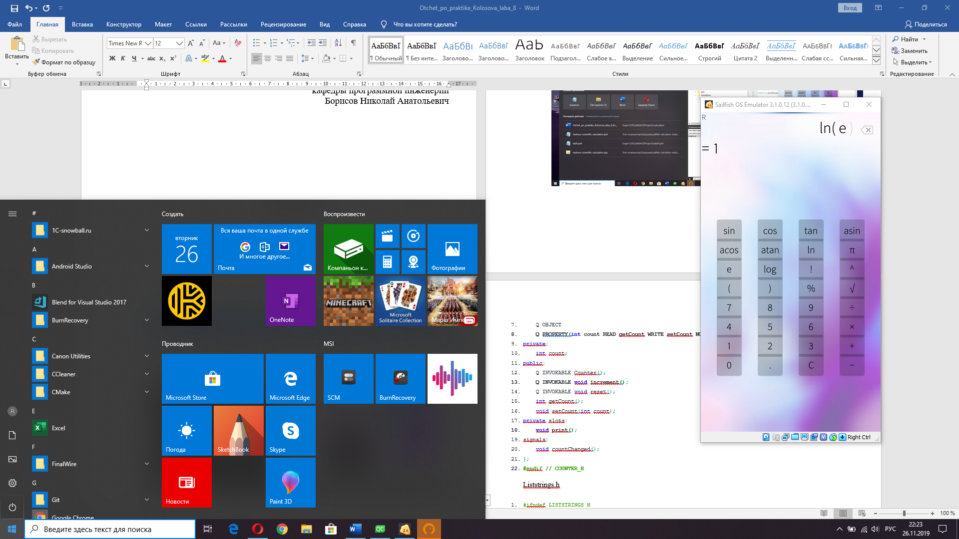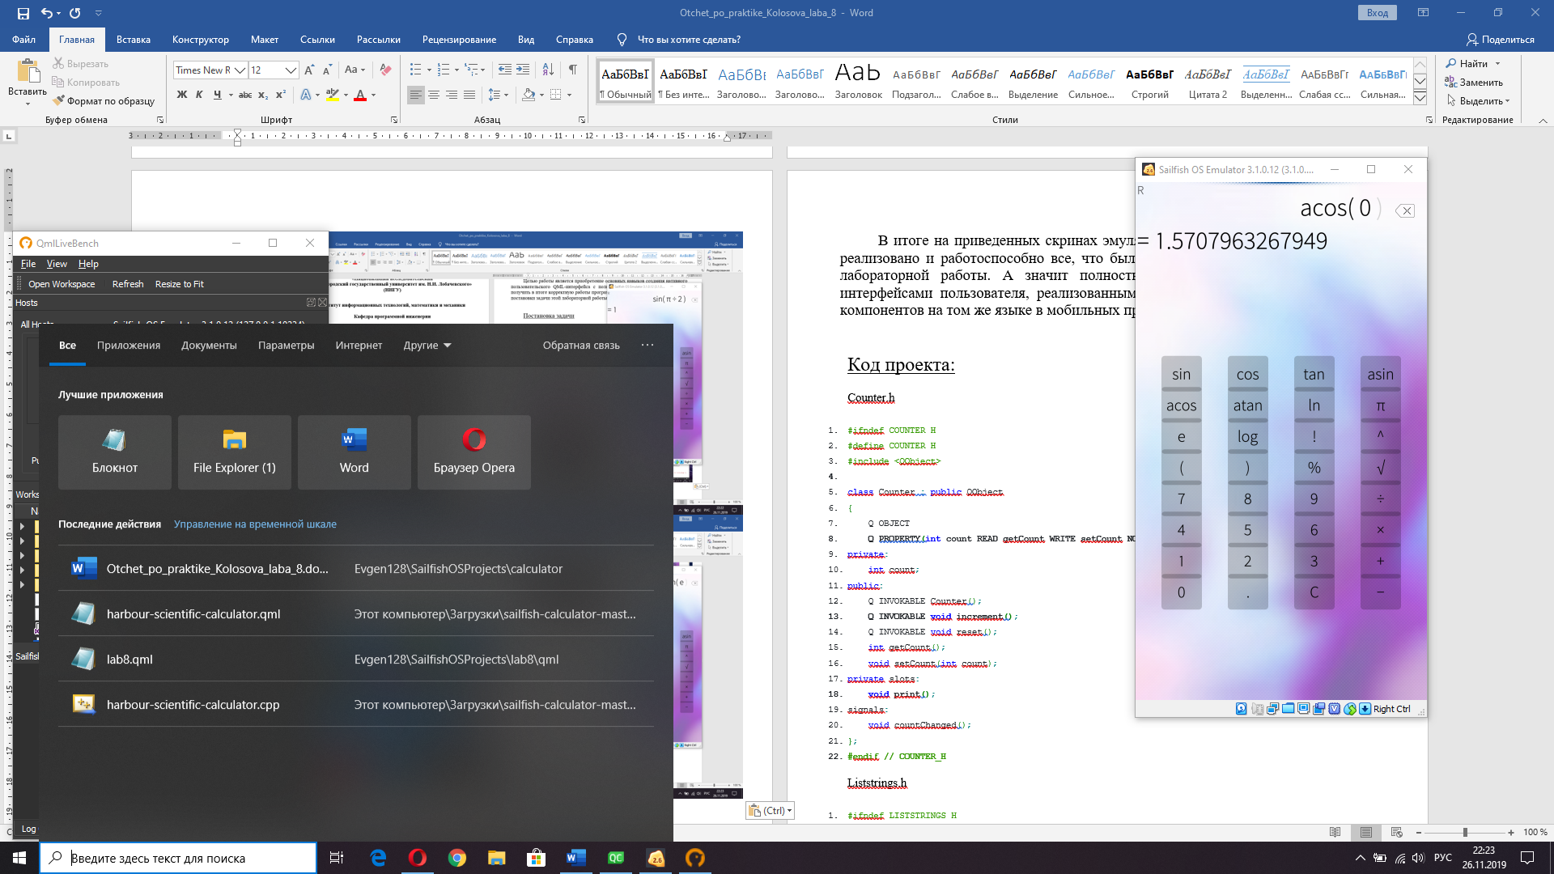 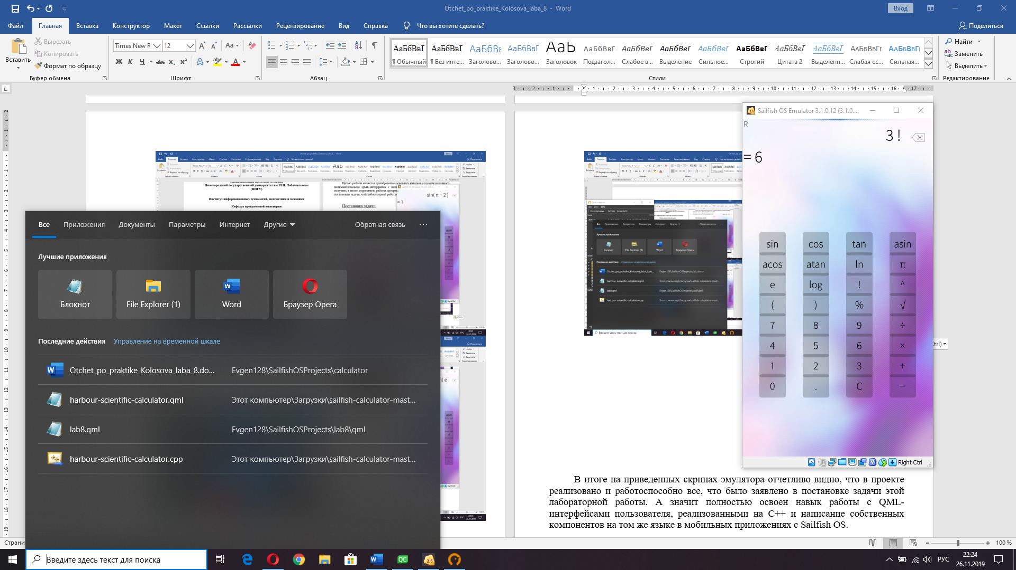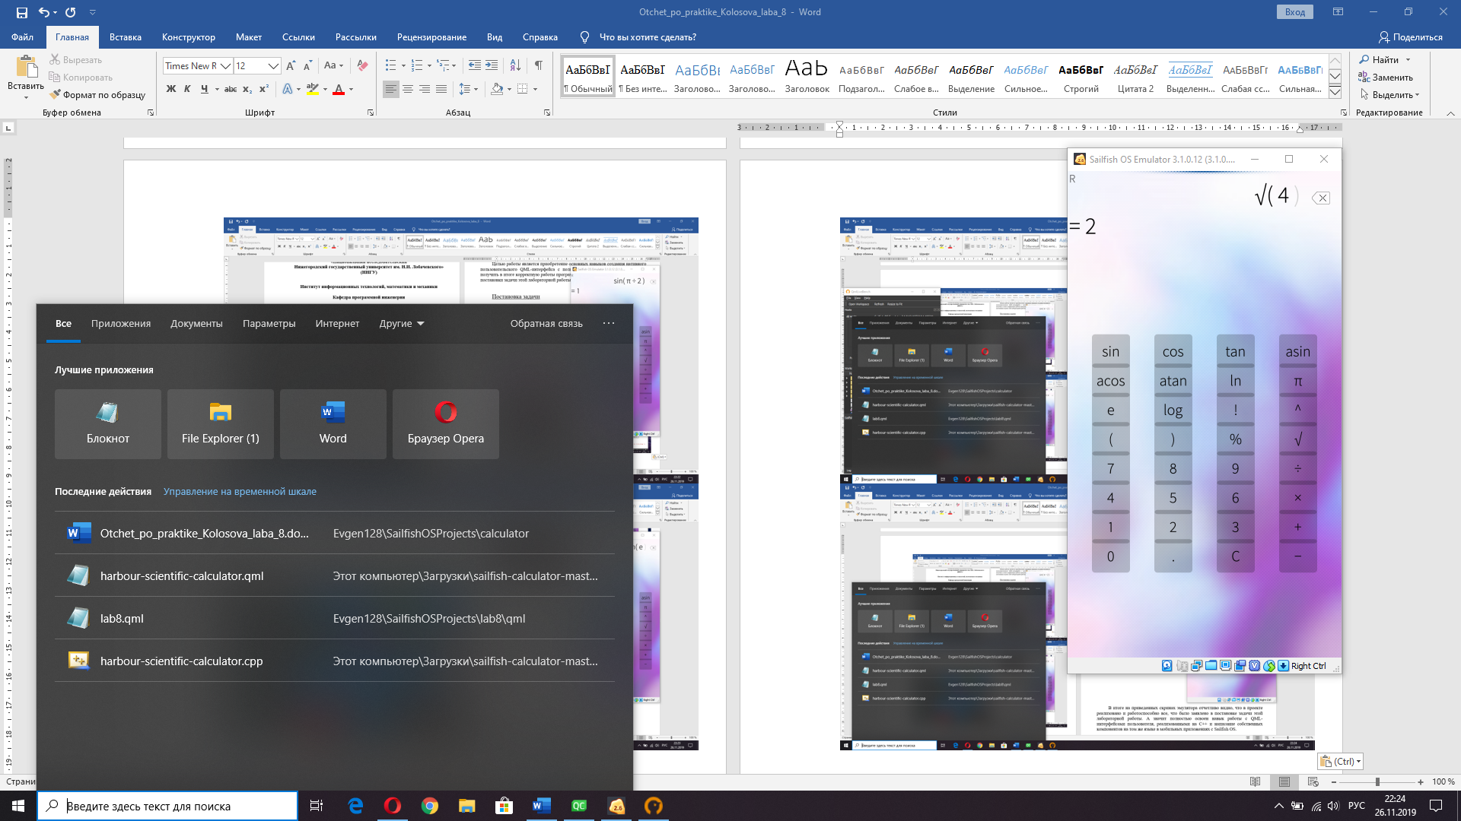 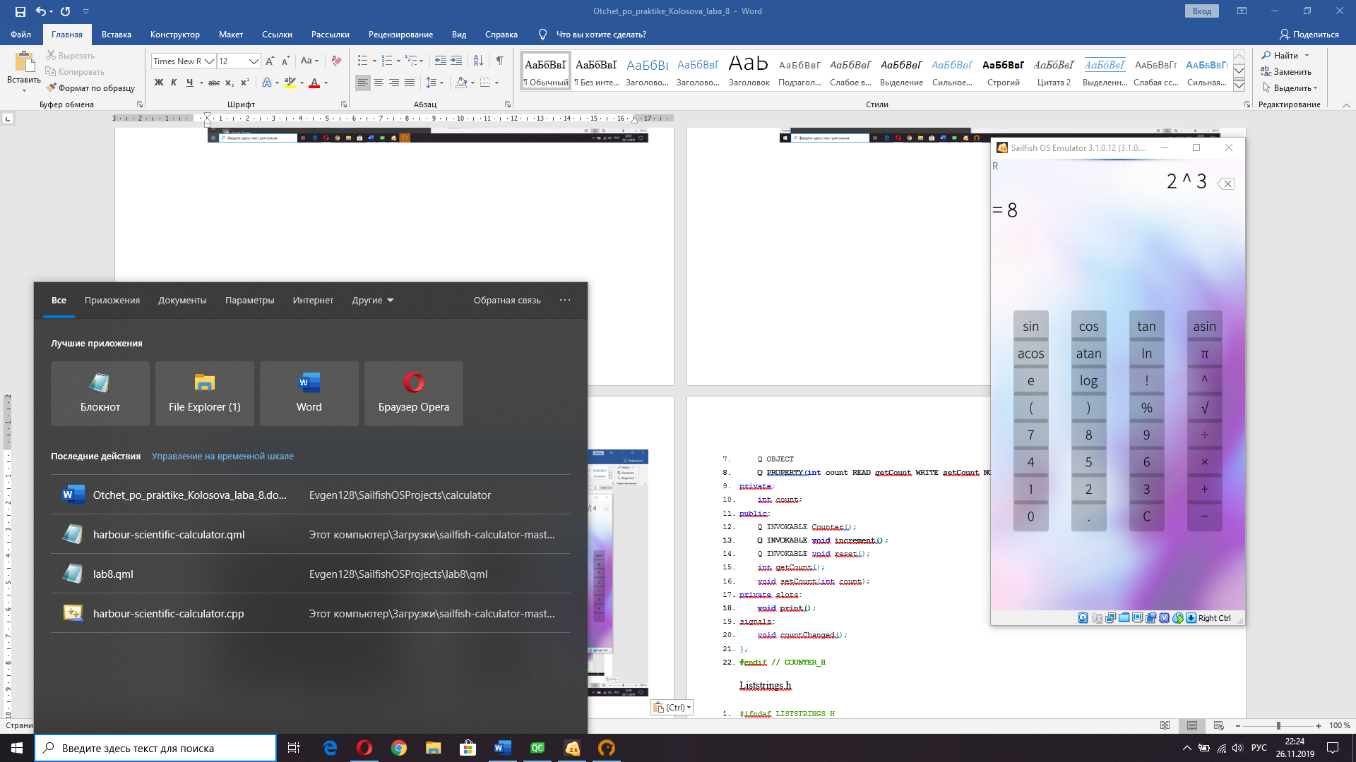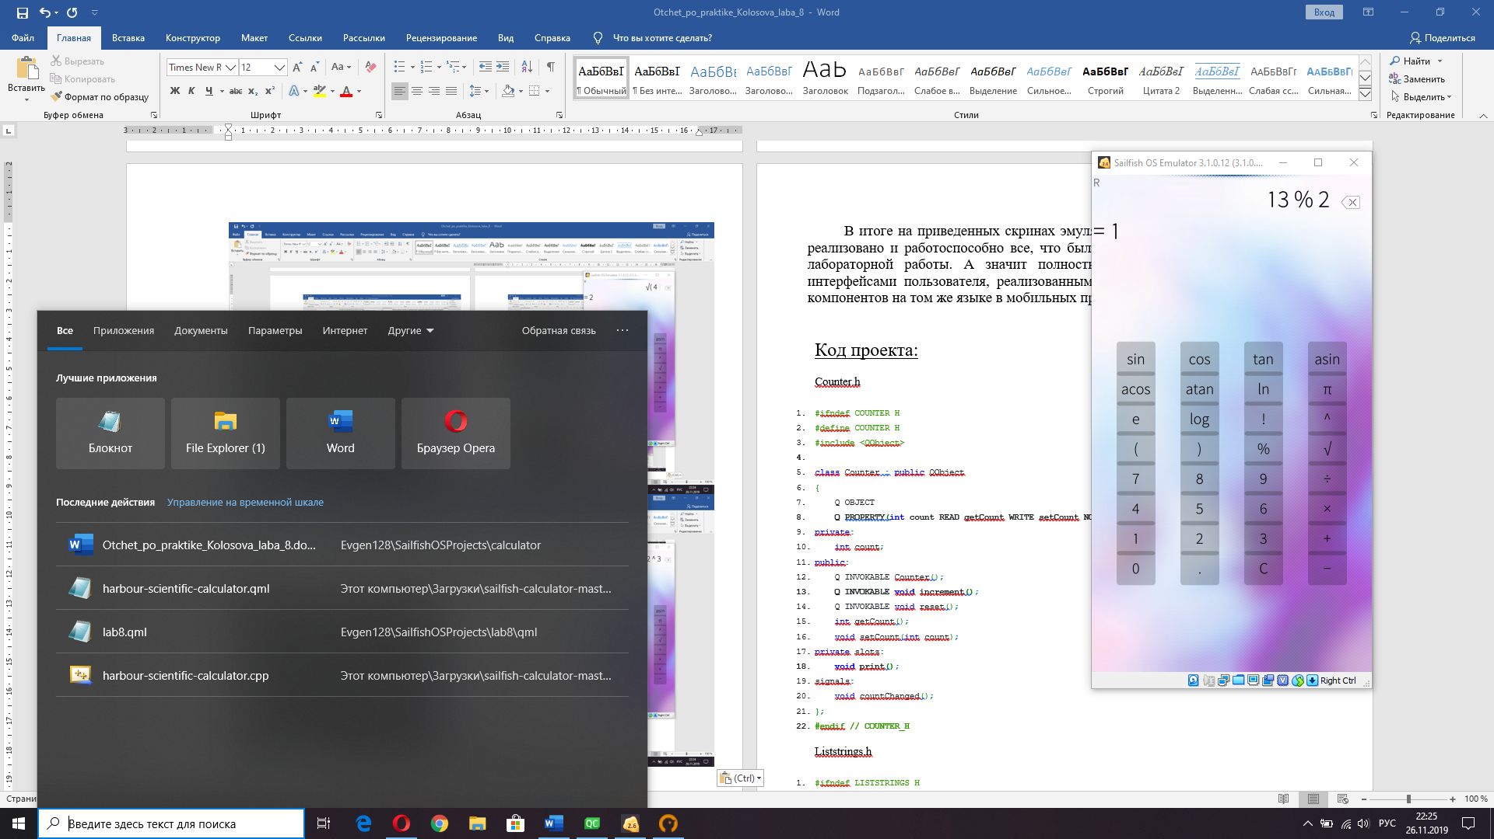 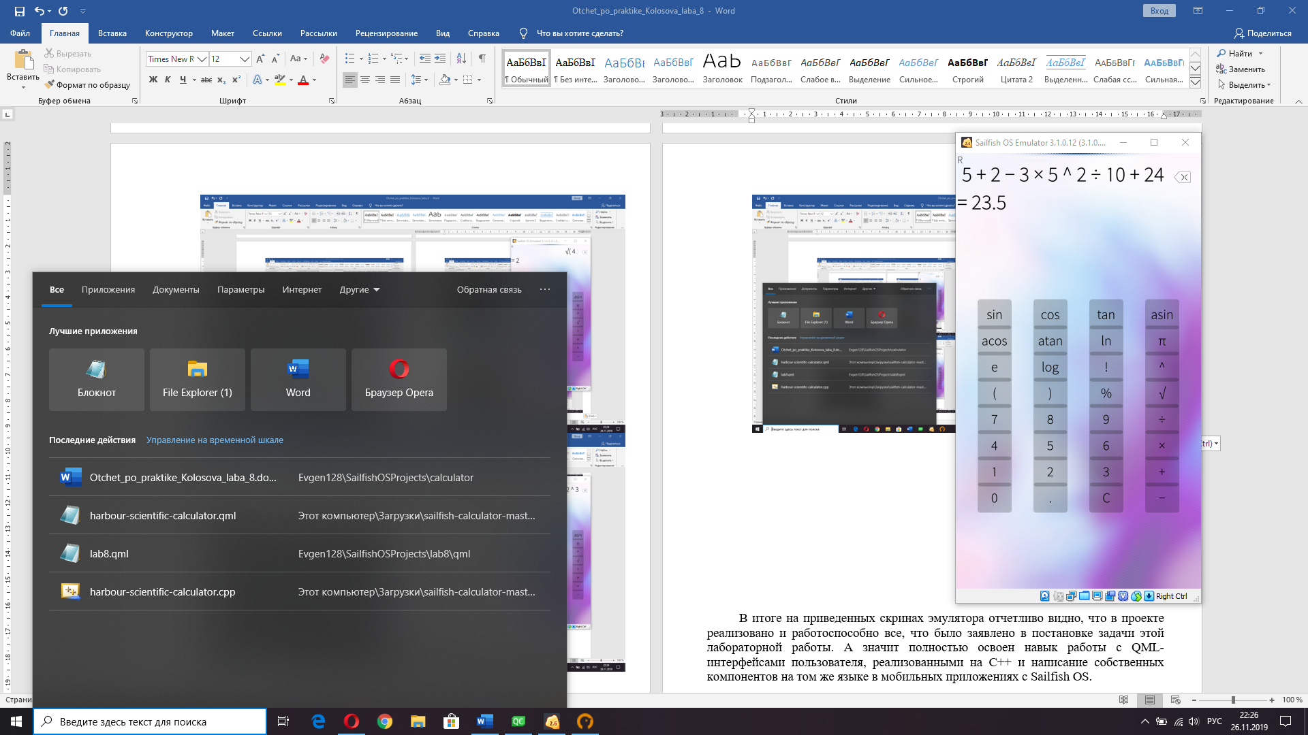 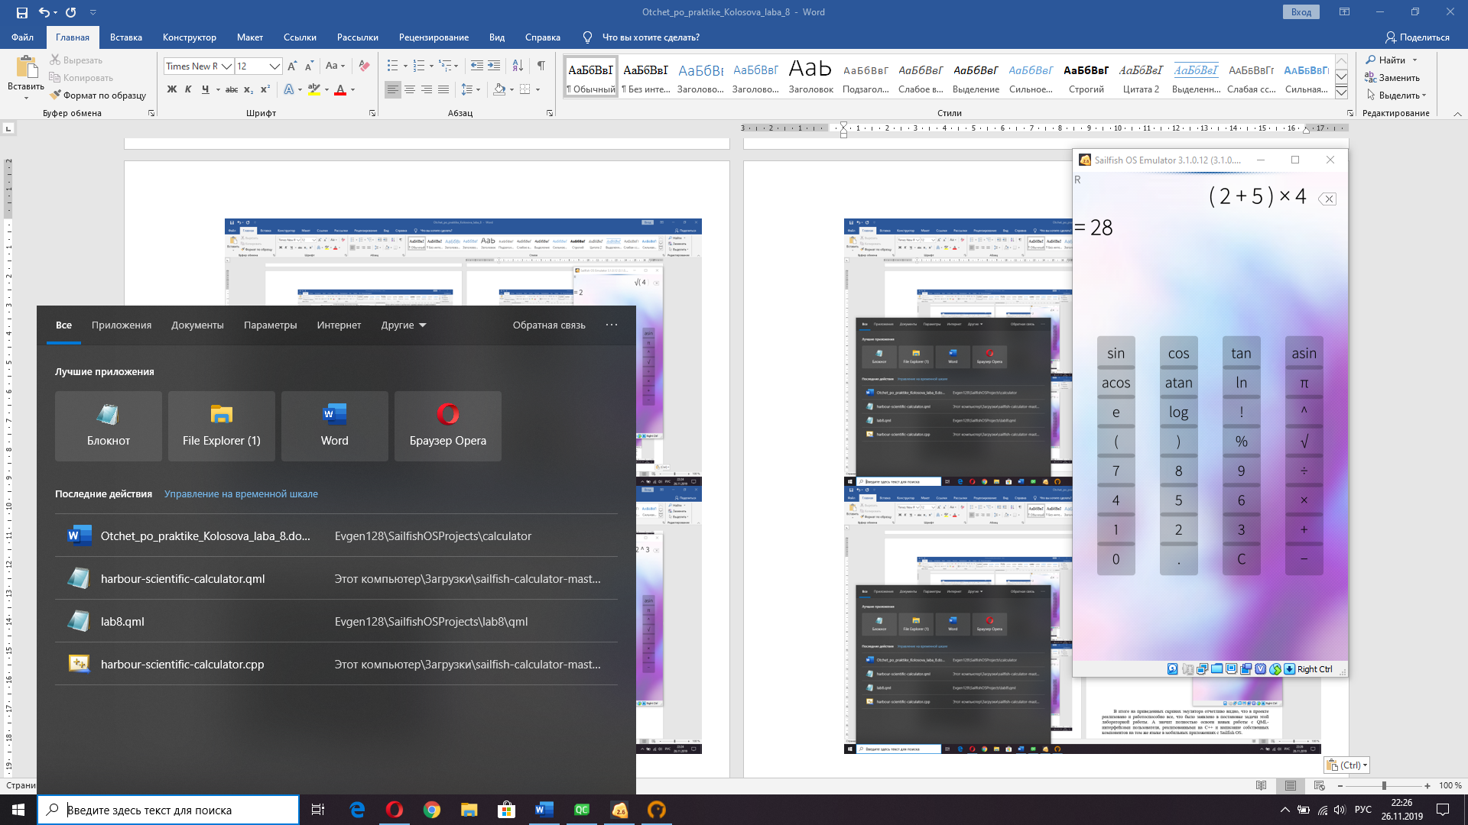 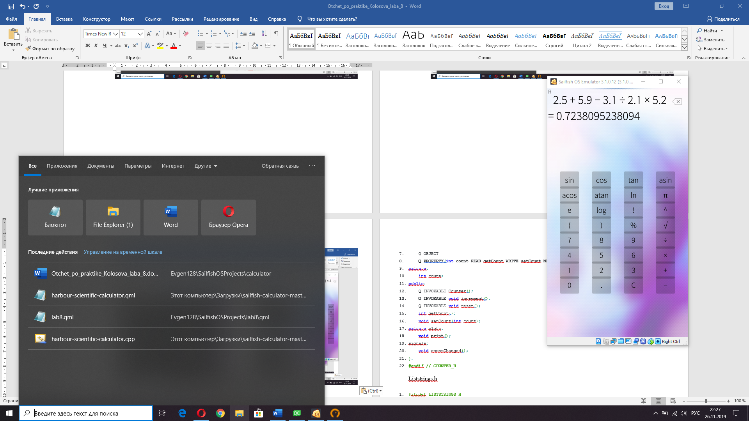

В итоге на приведенных скринах эмулятора отчетливо видно, что в проекте реализовано и работоспособно все, что было заявлено в постановке задачи этой лабораторной работы. А значит полностью освоен навык создания кастомных калькуляторов с основным функционалом и не содержащий ошибок расчетов.

Код проекта:

CoverPage.qml

1. import QtQuick 2.0
2. import Sailfish.Silica 1.0
4. CoverBackground {
5. **id: page**
6. Item {
7. id: keyboard
8. anchors {
9. top: page.top
10. **bottom: page.bottom**
11. left: page.left
12. right: page.right
13. }
15. **Label{**
16. anchors.centerIn: parent
17. text: "SciCalc"
18. color: Theme.secondaryColor
19. font.pixelSize: Theme.fontSizeExtraLarge
20. **}**
21. }
22. }

CalcScreen.qml

1. import QtQuick 2.0
2. import Sailfish.Silica 1.0
4. Item{
5. **id: root**
6. height: columnA.height + 30
7. transformOrigin: Item.Bottom
8. state: "current"
10. **signal useAnswer(string answerToUse, string formulaData)**
12. Column {
13. id: columnA
14. spacing: 10
15. **width: parent.width - 8**
16. anchors{
17. top: parent.top
18. left: parent.left
19. leftMargin: 4
20. **}**
22. Label{
23. id: drg
24. visible: isLastItem
25. **font.family: Theme.fontFamily**
26. font.pixelSize: Theme.fontSizeExtraSmall
27. color: Theme.secondaryColor
28. height: lineHeight + 10
29. text: angularUnit[0]
30. **}**
32. Row{
33. width: parent.width
34. height: formulaLabel.height
35. **spacing: 4**
36. Label {
37. id: formulaLabel
38. width: parent.width- backBtn.width -4
39. height: font.pixelSize + 10
40. **horizontalAlignment: Text.AlignRight**
41. font.family: Theme.fontFamily
42. font.pixelSize: Theme.fontSizeExtraLarge
43. text: formula
44. }
45. **IconButton{**
46. id: backBtn
47. visible: isLastItem
48. width: (!visible) ? 0 : height
49. icon.source: "image://Theme/icon-l-backspace"
50. **onClicked: formulaPop()**
51. onPressAndHold: formulaReset()
52. }
53. }
55. **Label {**
56. id: answerLabel
57. width: parent.width
58. height: font.pixelSize + 10
59. font.family: Theme.fontFamily
60. **font.pixelSize: Theme.fontSizeExtraLarge**
61. elide: Text.ElideRight
62. clip: **true**
63. text: '= %1'.arg(answer)
64. }
65. **}**
67. GlassItem {
68. id: divider
69. anchors.top: parent.top
70. **anchors.topMargin: (height/2)*-1**
71. anchors.horizontalCenter: parent.horizontalCenter
72. objectName: "menuitem"
73. height: Theme.paddingLarge
74. width: parent.width
75. **color: Theme.highlightColor**
76. cache: **false**
77. }
79. MouseArea {
80. **id: screenMA**
81. anchors.fill: parent
82. visible: !isLastItem
83. onClicked: {
84. **if** (answer.indexOf('error') == -1)
85. **root.useAnswer(answer, formula_data)**
86. }
87. }
89. states: [
90. **State {**
91. name: "one"
92. when: memory.count == 1
93. PropertyChanges {
94. target: divider
95. **visible: false**
96. }
97. },
98. State {
99. name: "more"
100. **when: memory.count > 1**
101. PropertyChanges {
102. target: divider
103. visible: **true**
104. }
105. **}**
106. ]
108. transitions: [
109. Transition {
110. **from: "one"**
111. to: "more"
112. NumberAnimation { target: divider; property: "opacity"; from: 0; to: 1; duration: 500 }
113. }
114. ]
115. **}**

KeyboardButton.qml

1. import QtQuick 2.0
2. import Sailfish.Silica 1.0
4. Button {
5. **id: buttonRect**
6. width: buttonWidth
7. height: buttonHeigt
8. }

Memory.qml

1. import QtQuick 2.0
3. ListModel {
4. id: memory
6. ListElement {
7. isLastItem: **true**
8. formula: ''
9. answer: ''
10. **formula_data: ''**
11. }
12. }

StdKeyboard.qml

1. import QtQuick 2.0
2. import Sailfish.Silica 1.0
4. Item {
5. **width: parent.width**
6. height: keyboard.height + 24
8. property int buttonWidth: 100
9. property int buttonHeigt: 65
11. Grid{
12. id: keyboard
13. columns: 4
15. **rowSpacing: 12**
16. columnSpacing: (parent.width - (buttonWidth * 4)) / 5
18. anchors.centerIn: parent
20. **KeyboardButton {**
21. text: "sin"
22. onClicked: formulaPush('sin', 'sin', 'function')
23. }
25. **KeyboardButton {**
26. text: "cos"
27. onClicked: formulaPush('cos', 'cos', 'function')
28. }
30. **KeyboardButton {**
31. text: "tan"
32. onClicked: formulaPush('tan', 'tan', 'function')
33. }
35. **KeyboardButton {**
36. text: "asin"
37. onClicked: formulaPush('asin', 'asin', 'function')
38. }
40. **KeyboardButton {**
41. text: "acos"
42. onClicked: formulaPush('acos', 'acos', 'function')
43. }
45. **KeyboardButton {**
46. text: "atan"
47. onClicked: formulaPush('atan', 'atan', 'function')
48. }

51. KeyboardButton {
52. text: "ln"
53. onClicked: formulaPush('ln', 'ln', 'function')
54. }
56. KeyboardButton {
57. text: "π"
58. onClicked: formulaPush('π', 'π', 'const')
59. }
61. KeyboardButton {
62. text: "e"
63. onClicked: formulaPush('e', 'E', 'const')
64. }
66. KeyboardButton {
67. text: "log"
68. onClicked: formulaPush('log', 'log', 'function')
69. }
71. KeyboardButton {
72. text: "!"
73. onClicked: formulaPush('!', '!', 'operation')
74. }
76. KeyboardButton {
77. text: "^"
78. onClicked: formulaPush('^', '^', 'operation')
79. }
81. KeyboardButton {
82. text: "("
83. onClicked: formulaPush('(', '(', 'group')
84. }
86. KeyboardButton {
87. text: ")"
88. onClicked: formulaPush(')', ')', 'group')
89. }
91. KeyboardButton {
92. text: "%"
93. onClicked: formulaPush('%', '%', 'operation')
94. }
96. KeyboardButton {
97. text: "√"
98. onClicked: formulaPush('√', '√', 'function')
99. }
101. KeyboardButton {
102. text: "7"
103. onClicked: formulaPush('7', '7', 'number')
104. }
106. KeyboardButton {
107. text: "8"
108. onClicked: formulaPush('8', '8', 'number')
109. }
111. KeyboardButton {
112. text: "9"
113. onClicked: formulaPush('9', '9', 'number')
114. }
116. KeyboardButton {
117. text: "÷"
118. onClicked: formulaPush('÷', '/', 'operation')
119. }
121. KeyboardButton {
122. text: "4"
123. onClicked: formulaPush('4', '4', 'number')
124. }
126. KeyboardButton {
127. text: "5"
128. onClicked: formulaPush('5', '5', 'number')
129. }
131. KeyboardButton {
132. text: "6"
133. onClicked: formulaPush('6', '6', 'number')
134. }
136. KeyboardButton {
137. text: "×"
138. onClicked: formulaPush('×', '*', 'operation')
139. }
141. KeyboardButton {
142. text: "1"
143. onClicked: formulaPush('1', '1', 'number')
144. }
146. KeyboardButton {
147. text: "2"
148. onClicked: formulaPush('2', '2', 'number')
149. }
151. KeyboardButton {
152. text: "3"
153. onClicked: formulaPush('3', '3', 'number')
154. }
156. KeyboardButton {
157. text: "+"
158. onClicked: formulaPush('+', '+', 'operation')
159. }
161. KeyboardButton {
162. text: "0"
163. onClicked: formulaPush('0', '0', 'number')
164. }
166. KeyboardButton {
167. text: "."
168. onClicked: formulaPush('.', '.', 'real')
169. }
171. KeyboardButton {
172. text: "C"
173. onClicked: {
174. formulaView.addCurrentToMemory();
175. **formulaReset();**
176. }
177. }
179. KeyboardButton {
180. **text: "−"**
181. onClicked: formulaPush('−', '-', 'operation')
182. }
184. }
185. **}**

Calculator.qml

1. import QtQuick 2.0
2. import Sailfish.Silica 1.0
3. import "../elements"
4. import "../engine.js" as CALC
6. Page {
7. id: page
9. property string formula_text: '';
10. **property string brackets_added: '';**
11. property string formula_text_for_engine: '';
12. property string answer: '';
13. property string angularUnit: "RAD"
15. **property var formula: []**
17. **function** formulaPush(visual, engine, type) {
18. **var** prev = **null**;
19. **if** (formula.length > 0)
20. **prev = formula[formula.length-1];**
22. **var** result = CALC.getFormulaTexts(prev, visual, engine, type, brackets_added.length/2)
24. **var** visual_text = result[0];
25. **var engine_text = result[1];**
26. **var** fixed_type = result[2];
27. **var** brackets_count = result[3];
29. brackets_added = brackets_added.substr(0, brackets_count*2);
31. **if** (visual_text !== **null** && engine_text !== **null**) {
32. formula_text += visual_text;
33. formula_text_for_engine += engine_text;
34. formula.push({'visual': visual_text, 'engine': engine_text, 'type': fixed_type});
36. answer = calculate()
37. }
38. }
40. **function formulaPop() {**
41. **if** (formula.length > 0) {
42. **var** prev = formula[formula.length-1];
43. formula_text = formula_text.substring(0, formula_text.length - prev.visual.length);
44. formula_text_for_engine = formula_text_for_engine.substring(0, formula_text_for_engine.length - prev.engine.length);
45. **if (prev.type === 'function' || (prev.type === 'group' && prev.engine === '(' || prev.engine === '*('))**
46. brackets_added = brackets_added.substring(0, brackets_added.length-2)
47. **else** **if** (prev.type === 'group' && prev.engine === ')')
48. brackets_added += " )"
49. formula.pop();
51. answer = calculate()
52. }
53. }
55. **function formulaReset() {**
56. formula_text = '';
57. formula_text_for_engine = '';
58. formula = [];
59. answer = "";
60. **brackets_added = '';**
61. }
63. **function** calculate() {
65. **var result = 0;**
66. **try** {
67. result = CALC.parse(angularUnit + formula_text_for_engine + brackets_added);
68. **if** (result === Number.POSITIVE_INFINITY)
69. result = '∞';
70. **else if (result === Number.NEGATIVE_INFINITY)**
71. result = '-∞';
72. } **catch**(exception) {
73. **if**(exception **instanceof** CALC.DivisionByZeroError){
74. result = "division by zero error";
75. **} else if(exception instanceof SyntaxError){**
76. result = "";
77. } **else** **if**(exception **instanceof** CALC.ParenthesisError){
78. **if**(exception.missing === '(')
79. brackets_added = brackets_added.substr(0, brackets_added.length-2);
80. **else**
81. brackets_added+=(' '+exception.missing);
82. result = calculate();
83. }
84. }
85. **return result;**
86. }
88. **function** addFromMemory(answerToAdd, formulaData) {
89. **if** (answerToAdd !== '' && answerToAdd.indexOf('error') === -1 && answerToAdd.indexOf('∞') === -1) {
90. **for (var i = 0; i < answerToAdd.length; i++)**
91. formulaPush(answerToAdd[i], answerToAdd[i], answerToAdd[i] === '.' ? 'real' : 'number')
92. }
93. **else** {
94. **var** fd = JSON.parse(formulaData);
96. **var** prev = **null**;
97. **if** (formula.length > 0)
98. prev = formula[formula.length-1];
100. **var result = CALC.getFormulaTexts(prev, fd[0].engine, fd[0].engine, fd[0].type, brackets_added.length/2)**
102. **if** (result[0] !== **null** && result[1] !== **null**) {
103. **for** (**var** idx = 0; idx < fd.length; idx++) {
104. formula_text += fd[idx].visual;
105. **formula_text_for_engine += fd[idx].engine;**
106. formula.push({'visual': fd[idx].visual, 'engine': fd[idx].engine, 'type': fd[idx].type});
107. }
108. answer = calculate()
109. }
110. **}**
111. }
113. *// To enable PullDownMenu for different triginimetric func, place our content in a SilicaFlickable*
114. SilicaListView {
115. **id: formulaView**
116. anchors.fill: parent
117. snapMode: ListView.SnapOneItem

120. **property string currentFormula: '%1<font color="lightgray">%2</font>'.arg(formula_text).arg(brackets_added)**
121. property string currentAnswer: answer
122. property int screenHeight: 0
124. **function** addCurrentToMemory() {
125. **if(formula_text === '') return;**
126. memory.**get**(memory.count-1).isLastItem = **false**
127. memory.**get**(memory.count-1).formula_data = JSON.stringify(formula)
128. memory.append({'formula': memory.**get**(memory.count-1).formula, 'answer': memory.**get**(count-1).answer, 'formula_data': '', 'isLastItem': **true**})
129. positionViewAtIndex(memory.count-1, ListView.Beginning);
130. **}**
132. **function** showError() {
133. animateError.start()
134. }
136. PropertyAnimation {id: animateError; target: formulaView; properties: "color"; from: "#FFA0A0"; to: "#FFFFFF"; duration: 100}
138. delegate: CalcScreen {
139. id: calcScreen
140. **width: formulaView.width**
142. onUseAnswer: addFromMemory(answerToUse, formulaData)
144. Component.onCompleted: {
145. **if (formulaView.screenHeight == 0)**
146. formulaView.screenHeight = height
147. }
148. }
150. **footer: StdKeyboard{**
151. width: parent.width
152. height: page.height - formulaView.screenHeight
153. }
155. **model: Memory { id: memory }**
157. onCurrentFormulaChanged: {
158. memory.**get**(memory.count-1).formula = currentFormula
159. positionViewAtIndex(memory.count-1, ListView.Beginning);
160. **}**
162. onCurrentAnswerChanged: {
163. memory.**get**(memory.count-1).answer = currentAnswer
164. }
165. **}**
166. }

Engine.js

1. .pragma library
2. **var MAX_DECIMAL = 13; *// Number of maximum decimal positions***
4. **var** RAD = 0; *//Trigonometric function*
6. *// ----------------------------------------*
7. ***// utils***
8. **function** stripFloat(number){
9. **return** parseFloat(number.toFixed(MAX_DECIMAL));
10. }
12. ***// ----------------------------------------***
13. *// exceptions*
14. **function** DivisionByZeroError(message){
15. **this**.message = message;
16. }
18. DivisionByZeroError.**prototype** = **new** Error();
20. **function** ParenthesisError(message, missing){
21. **this**.message = message;
22. **this.missing = missing;**
23. }
25. ParenthesisError.**prototype** = **new** Error();
27. ***// ----------------------------------------***
28. *// Math customizations*
29. Math._sin = Math.sin;
30. Math._cos = Math.cos;
31. Math._tan = Math.tan;
32. **Math._asin = Math.asin;**
33. Math._acos = Math.acos;
34. Math._atan = Math.atan;
36. Math.sin = **function**(x, mode){
37. **switch(mode){**
38. **case** **undefined**:
39. **case** RAD:
40. **return** Math._sin(x);
41. }
42. **}**
44. Math.cos = **function**(x, mode){
45. **switch**(mode){
46. **case** **undefined**:
47. **case RAD:**
48. **return** Math._cos(x);
49. }
50. }
52. **Math.tan = function(x, mode){**
53. **switch**(mode){
54. **case** **undefined**:
55. **case** RAD:
56. **return** Math._tan(x);
57. **}**
58. }
60. Math.asin = **function**(x, mode){
61. **switch**(mode){
62. **case undefined:**
63. **case** RAD:
64. **return** Math._asin(x);
65. }
66. }
68. Math.acos = **function**(x, mode){
69. **switch**(mode){
70. **case** **undefined**:
71. **case** RAD:
72. **return Math._acos(x);**
73. }
74. }
76. Math.atan = **function**(x, mode){
77. **switch(mode){**
78. **case** **undefined**:
79. **case** RAD:
80. **return** Math._atan(x);
81. }
82. **}**
84. Math.log10 = **function**(x){
85. **return** Math.log(x) / Math.LN10;
86. }
88. Math.log2 = **function**(x){
89. **return** Math.log(x) / Math.LN2;
90. }
92. **Math.factorial = function(x){**
93. **var** cache = [1, 1, 2, 6, 24, 120, 720, 5040, 40320, 362880, 3628800, 39916800, 479001600, 6227020800, 87178291200, 1307674368000, 20922789888000, 355687428096000, 6402373705728000, 121645100408832000, 2432902008176640000]
94. **var** abs_x = Math.abs(x);
95. **if**(abs_x<=20 && abs_x % 1 === 0){
96. **var** res = (abs_x > 0) ? (abs_x/x)*cache[abs_x] : cache[abs_x];
97. **return res;**
98. }
100. *// Lanczos Approximation of the Gamma Function*
101. *// As described in Numerical Recipes in C (2nd ed. Cambridge University Press, 1992)*
102. **var z = x + 1;**
103. **var** p = [1.000000000190015, 76.18009172947146, -86.50532032941677, 24.01409824083091, -1.231739572450155, 1.208650973866179E-3, -5.395239384953E-6];
105. **var** d1 = Math.sqrt(2 * Math.PI) / z;
106. **var** d2 = p[0];
108. **for** (**var** i = 1; i <= 6; ++i)
109. d2 += p[i] / (z + i);
111. **var** d3 = Math.pow((z + 5.5), (z + 0.5));
112. **var d4 = Math.exp(-(z + 5.5));**
114. **return** d1 * d2 * d3 * d4;
115. }
116. **var** T_UNMATCHED = 0,
117. T_NUMBER = 1, *// number*
118. T_IDENT = 2, *// ident (constant)*
119. **T_FUNCTION = 4, *// function***
120. T_POPEN = 8, *// (*
121. T_PCLOSE = 16, *// )*
122. T_COMMA = 32, *// ,*
123. T_OPERATOR = 64, *// operator*
124. **T_PLUS = 65, *// +***
125. T_MINUS = 66, *// -*
126. T_TIMES = 67, *// \**
127. T_DIV = 68, *// /*
128. T_MOD = 69, *// %*
129. **T_POW = 70, *// ^***
130. T_UNARY_PLUS = 71, *// unary +*
131. T_UNARY_MINUS = 72, *// unary -*
132. T_FACTORIAL = 73, *// ! factorial function*
133. T_MODE = 128;*// RAD*
134. **function** Token(value, type) {
135. **this**.value = value;
136. **this.type = type;**
137. }
139. Token.**prototype** = {
140. constructor: Token,
141. *// if token is a function:*
142. *// save argument-count*
143. argc: 0
144. }
145. **function** Stack() {
146. **this**.index = -1;
147. **}**
149. Stack.**prototype** = {
150. constructor: Stack,
152. **length: 0,**
154. push: Array.**prototype**.push,
155. pop: Array.**prototype**.pop,
156. shift: Array.**prototype**.shift,
157. **unshift: Array.prototype.unshift,**
159. first: **function** first() {
160. **return** **this**[0];
161. },
162. last: **function** last() {
163. **return** **this**[**this**.length - 1];
164. },
165. peek: **function** peek() {
166. **return** **this**[**this**.index + 1];
167. },
168. next: **function** next() {
169. **return** **this**[++**this**.index];
170. },
171. prev: **function** prev() {
172. **return** **this**[--**this**.index];
173. }
174. }
175. **function** Context() { *//function names cannot contain numbers*
176. **this**.fnt = {
177. '√': Math.sqrt,
178. **"ln": Math.log,**
179. "log": Math.log10,
180. "sin": Math.sin,
181. "cos": Math.cos,
182. "tan": Math.tan,
183. **"asin": Math.asin,**
184. "acos": Math.acos,
185. "atan": Math.atan
186. };
187. **this**.cst = {
188. **'π': Math.PI,**
189. 'E': Math.E
190. };
191. }
192. **Context.prototype = {**
193. constructor: Context,
195. fn: **function** fn(name, args) {
196. **if** (**typeof** **this**.fnt[name] !== 'function')
197. **throw new SyntaxError('function "' + name + '" is not defined');**
199. **var** fnc = **this**.fnt[name];
200. **return** fnc.apply(fnc, args);
201. },
203. cs: **function** cs(name) {
204. **if** (**typeof** **this**.cst[name] === 'undefined')
205. **throw** **new** SyntaxError('constant "' + name + '" is not defined');
207. **return this.cst[name];**
208. },
210. def: **function** def(name, value) {
211. **if** (**typeof** value === 'undefined' && **typeof** Math[name] === 'function')
212. **value = Math[name].bind(Math);**
214. **if** (**typeof** value === 'function')
215. **this**.fnt[name] = value;
217. **else if (typeof value === 'number')**
218. **this**.cst[name] = value;
220. **else** **throw** **new** SyntaxError('function or number expected');
222. **return this;**
223. },
225. getFntRegExp: **function** getFntRegExp(){
226. **var** res = "";
227. **for(var f in this.fnt){**
228. res += f+"|";
229. }
230. **return** res.substring(0, res.length-1);
231. },
233. getCstRegExp: **function** getCstRegExp(){
234. **var** res = "";
235. **for**(**var** c **in** **this**.cst){
236. res += "**\\**"+c;
237. **}**
238. **return** res;
239. }
240. }
241. **function** Scanner(term, context) {
242. **this**.tokens = **new** Stack;
243. **this.context = context;**
244. **this**.mode = RAD;
246. **var** prev = { type: T_OPERATOR }; *// dummy*
247. **var** match, token, type;
248. **var RE_PATTERN = new RegExp("^([!,\\+\\-\\*\\/\\^%\\(\\)"**
249. +context.getCstRegExp()
250. +"]|RAD"
251. +"|**\\**d*(**\\**.**\\**d+)?e[-+]**\\**d+|**\\**d\***\\**.**\\**d+|**\\**d+**\\**.**\\**d*|**\\**d+|"
252. +context.getFntRegExp()
253. **+"|[ \\t]+)");**
254. while (term.length) {
255. **if** (!(match = term.match(RE_PATTERN)))
256. **throw** **new** SyntaxError('error near `' + term.substr(0, 10) + '``');
258. **if** ((token = match[1]).length === 0)
259. **throw** **new** SyntaxError('empty token matched. abort');
261. term = term.substr(token.length);
263. **if** ((token = token.trim()).length === 0)
264. **continue**; *// whitespace*
266. **if** (!isNaN(token)) {
267. **if(prev.type === T_IDENT || prev.type === T_PCLOSE)**
268. **this**.tokens.push(**new** Token('*', T_TIMES));
269. **this**.tokens.push(prev = **new** Token(parseFloat(token), T_NUMBER));
270. **continue**;
271. }
273. **switch** (type = **this**.lookup[token] || T_UNMATCHED) {
274. **case** T_PLUS:
275. **if** ((prev.type & T_OPERATOR && prev.type != T_FACTORIAL) || prev.type === T_POPEN) type = T_UNARY_PLUS;
276. **break**;
278. **case** T_MINUS:
279. **if** ((prev.type & T_OPERATOR &&prev.type != T_FACTORIAL)|| prev.type === T_POPEN) type = T_UNARY_MINUS;
280. **break**;
282. **case T_IDENT:**
283. **case** T_UNMATCHED:
284. **switch** (prev.type){
285. **case** T_IDENT:
286. **case** T_PCLOSE:
287. **case T_NUMBER:**
288. **this**.tokens.push(**new** Token('*', T_TIMES));
289. **break**;
290. }
291. **break**;
293. **case** T_POPEN:
294. **switch** (prev.type) {
295. **case** T_UNMATCHED:
296. prev.type = T_FUNCTION;
297. **break;**
299. **case** T_NUMBER:
300. **case** T_PCLOSE:
301. **case** T_IDENT:
302. **this.tokens.push(new Token('*', T_TIMES));**
303. **break**;
304. }
305. **break**;
307. **case T_MODE:**
308. **switch**(token){
309. **case** "RAD":
310. **this**.mode = RAD;
311. **break**;
312. **}**
313. **continue**;
314. }
315. **this.tokens.push(prev = new Token(token, type));**
316. }
317. }
318. Scanner.**prototype** = {
319. **constructor: Scanner,**
321. lookup: {
322. '+': T_PLUS,
323. '-': T_MINUS,
324. **'*': T_TIMES,**
325. '/': T_DIV,
326. '%': T_MOD,
327. '^': T_POW,
328. '(': T_POPEN,
329. **')': T_PCLOSE,**
330. ',': T_COMMA,
331. '!': T_FACTORIAL,
332. 'π': T_IDENT,
333. 'E': T_IDENT,
334. **'RAD': T_MODE**
335. },
337. prev: **function** prev() { **return** **this**.tokens.prev(); },
338. next: **function** next() { **return** **this**.tokens.next(); },
339. **peek: function peek() { return this.tokens.peek(); }**
340. }
341. **function** Parser(scanner) {
342. **this**.scanner = scanner;
344. **this**.queue = **new** Stack;
345. **this.stack = new Stack;**
347. **var** token;
349. while ((token = **this**.scanner.next()) !== **undefined**)
350. **this.handle(token);**
352. while ((token = **this**.stack.pop()) !== **undefined**) {
353. **if** (token.type === T_POPEN)
354. **throw** **new** ParenthesisError('unmatched parentheses', ')');
355. **if (token.type === T_PCLOSE)**
356. **throw** **new** ParenthesisError('unmatched parentheses', '(');
357. **this**.queue.push(token);
358. }
359. }
361. Parser.**prototype** = {
362. constructor: Parser,
364. reduce: **function** reduce(ctx) {
365. **this.stack = new Stack;**
366. **var** len = 0, token;
368. *// While there are input tokens left*
369. *// Read the next token from input.*
370. **while ((token = this.queue.shift()) !== undefined) {**
371. **switch** (token.type) {
372. **case** T_NUMBER:
373. **case** T_IDENT:
374. *// evaluate constant*
375. **if (token.type === T_IDENT)**
376. token = **new** Token(ctx.cs(token.value), T_NUMBER);
378. *// If the token is a value or identifier*
379. *// Push it onto the stack.*
380. **this.stack.push(token);**
381. ++len;
382. **break**;
384. **case** T_PLUS:
385. **case T_MINUS:**
386. **case** T_UNARY_PLUS:
387. **case** T_UNARY_MINUS:
388. **case** T_FACTORIAL:
389. **case** T_TIMES:
390. **case T_DIV:**
391. **case** T_MOD:
392. **case** T_POW:
393. *// It is known a priori that the operator takes n arguments.*
394. **var** argc = **this**.argc(token);
396. *// If there are fewer than n values on the stack*
397. **if** (len < argc)
398. **throw** **new** SyntaxError('too few arguments for operator `' + token.value + '`');
400. **var rhs = this.stack.pop(),**
401. lhs = **null**;
403. **if** (argc === 2) lhs = **this**.stack.pop();
405. **len -= (argc - 1);**
407. *// Push the returned results, if any, back onto the stack.*
408. **this**.stack.push(**new** Token(**this**.op(token.type, lhs, rhs), T_NUMBER));
409. **break**;
411. **case** T_FUNCTION:
412. *// function*
413. **var** argc = token.argc,
414. argv = [];
416. len -= (argc - 1);
418. **for** (; argc > 0; --argc)
419. argv.unshift(**this**.stack.pop().value);
421. **if** (token.value == "sin" || token.value == "cos" || token.value == "tan" ||
422. token.value == "asin" || token.value == "acos" || token.value == "atan"){
423. argv.push(**this**.scanner.mode);
424. }
426. *// Push the returned results, if any, back onto the stack.*
427. **this**.stack.push(**new** Token(stripFloat(ctx.fn(token.value, argv)), T_NUMBER));
428. **break**;
430. **default:**
431. **throw** **new** SyntaxError('unexpected token "' + token.value + '"');
432. }
433. }
435. ***// If there is only one value in the stack***
436. *// That value is the result of the calculation.*
437. **if** (**this**.stack.length === 1)
438. **return** **this**.stack.pop().value;
440. ***// If there are more values in the stack***
441. *// (Error) The user input has too many values.*
442. console.log(**this**.queue.length)
443. **throw** **new** Error('runtime error: too many values');
444. },
446. op: **function** op(type, lhs, rhs) {
447. **if** (lhs !== **null**) {
448. **switch** (type) {
449. **case** T_PLUS:
450. **return stripFloat(lhs.value + rhs.value);**
452. **case** T_MINUS:
453. **return** stripFloat(lhs.value - rhs.value);
455. **case T_TIMES:**
456. **return** stripFloat(lhs.value * rhs.value);
458. **case** T_DIV:
459. **return** stripFloat(lhs.value / rhs.value);
461. **case** T_MOD:
462. **if** (rhs.value === 0.)
463. **throw** **new** DivisionByZeroError('modulo division by zero');
465. **return lhs.value % rhs.value;**
467. **case** T_POW:
468. **return** Math.pow(lhs.value, rhs.value);
469. }
470. **return** 0.;
471. }
473. **switch (type) {**
474. **case** T_UNARY_MINUS:
475. **return** -rhs.value;
477. **case** T_UNARY_PLUS:
478. **return +rhs.value;**
480. **case** T_FACTORIAL:
481. **return** stripFloat(Math.factorial(rhs.value));
482. }
483. **return** 0.;
484. },
486. **argc: function argc(token) {**
487. **switch** (token.type) {
488. **case** T_PLUS:
489. **case** T_MINUS:
490. **case** T_TIMES:
491. **case T_DIV:**
492. **case** T_MOD:
493. **case** T_POW:
494. **return** 2;
495. }
497. **return** 1;
498. },
500. fargs: **function** fargs(fn) {
501. **this.handle(this.scanner.next()); *// '('***
503. **var** argc = 0,
504. next = **this**.scanner.peek();
506. **if (next !== undefined && next.type !== T_PCLOSE) {**
507. argc = 1;
509. while ((next = **this**.scanner.next()) !== **undefined**) {
510. **this**.handle(next);
512. **if** (next.type === T_PCLOSE)
513. **break**;
515. **if** (next.type === T_COMMA)
516. **++argc;**
517. }
518. }
520. fn.argc = argc;
521. **},**
523. handle: **function** handle(token) {
524. **switch** (token.type) {
525. **case** T_NUMBER:
526. **case T_IDENT:**
527. *// If the token is a number (identifier), then add it to the output queue.*
528. **this**.queue.push(token);
529. **break**;
531. **case T_FUNCTION:**
532. *// If the token is a function token, then push it onto the stack.*
533. **this**.stack.push(token);
534. **this**.fargs(token);
535. **break**;

538. **case** T_COMMA:
539. *// If the token is a function argument separator (e.g., a comma):*
540. **var** pe = **false**;
542. while ((token = **this**.stack.last()) !== **undefined**) {
543. **if** (token.type === T_POPEN) {
544. pe = **true**;
545. **break**;
546. **}**
548. *// Until the token at the top of the stack is a left parenthesis,*
549. *// pop operators off the stack onto the output queue.*
550. **this**.queue.push(**this**.stack.pop());
551. **}**
553. *// If no left parentheses are encountered, either the separator was misplaced*
554. *// or parentheses were mismatched.*
555. **if** (pe !== **true**)
556. **throw new Error('parser error: misplaced `,` or unmatched parentheses');**
558. **break**;
560. *// If the token is an operator, op1, then:*
561. **case T_PLUS:**
562. **case** T_MINUS:
563. **case** T_UNARY_PLUS:
564. **case** T_UNARY_MINUS:
565. **case** T_FACTORIAL:
566. **case T_TIMES:**
567. **case** T_DIV:
568. **case** T_MOD:
569. **case** T_POW:
570. **var** token2;
572. both: while ((token2 = **this**.stack.last()) !== **undefined**) {
573. *// While there is an operator token, o2, at the top of the stack*
574. *// op1 is left-associative and its precedence is less than or equal to that of op2,*
575. *// or op1 has precedence less than that of op2,*
576. ***// Let + and ^ be right associative.***
577. *// Correct transformation from 1^2+3 is 12^3+*
578. *// The differing operator priority decides pop / push*
579. *// If 2 operators have equal priority then associativity decides.*
580. **switch** (token2.type) {
581. **default: break both;**
582. **case** T_PLUS:
583. **case** T_MINUS:
584. **case** T_UNARY_PLUS:
585. **case T_UNARY_MINUS:**
586. **case** T_FACTORIAL:
587. **case** T_TIMES:
588. **case** T_DIV:
589. **case** T_MOD:
590. **case T_POW:**
591. **var** p1 = **this**.preced(token),
592. p2 = **this**.preced(token2);
594. **if** (!((**this**.assoc(token) === 1 && (p1 <= p2)) || (p1 < p2)))
595. **break both;**
597. *// Pop o2 off the stack, onto the output queue;*
598. **this**.queue.push(**this**.stack.pop());
599. }
600. **}**
601. *// push op1 onto the stack.*
602. **this**.stack.push(token);
603. **break**;
605. **case** T_POPEN:
606. *// If the token is a left parenthesis, then push it onto the stack.*
607. **this**.stack.push(token);
608. **break**;
610. *// If the token is a right parenthesis:*
611. **case** T_PCLOSE:
612. **var** pe = **false**;
614. ***// Until the token at the top of the stack is a left parenthesis,***
615. *// pop operators off the stack onto the output queue*
616. while ((token = **this**.stack.pop()) !== **undefined**) {
617. **if** (token.type === T_POPEN) {
618. *// Pop the left parenthesis from the stack, but not onto the output queue.*
619. **pe = true;**
620. **break**;
621. }
623. **this**.queue.push(token);
624. **}**
626. *// If the stack runs out without finding a left parenthesis, then there are mismatched parentheses.*
627. **if** (pe !== **true**)
628. **throw** **new** ParenthesisError('unmatched parentheses', '(');
630. *// If the token at the top of the stack is a function token, pop it onto the output queue.*
631. **if** ((token = **this**.stack.last()) !== **undefined** && token.type === T_FUNCTION)
632. **this**.queue.push(**this**.stack.pop());
634. **break;**
636. **default**:
637. **throw** **new** SyntaxError('unknown token "' + token.value + '"');
638. }
639. **},**
640. assoc: **function** assoc(token) {
641. **switch** (token.type) {
642. **case** T_TIMES:
643. **case T_DIV:**
644. **case** T_MOD:
646. **case** T_PLUS:
647. **case** T_MINUS:
648. **return 1; *//ltr***
650. **case** T_UNARY_PLUS:
651. **case** T_UNARY_MINUS:
653. **case T_POW:**
654. **return** 2; *//rtl*
655. }
657. **return 0; *//nassoc***
658. },
659. preced: **function** preced(token) {
660. **switch** (token.type) {
661. **case T_UNARY_PLUS:**
662. **case** T_UNARY_MINUS:
663. **case** T_FACTORIAL:
664. **return** 4;
666. **case T_POW:**
667. **return** 3;
669. **case** T_TIMES:
670. **case** T_DIV:
671. **case T_MOD:**
672. **return** 2;
674. **case** T_PLUS:
675. **case** T_MINUS:
676. **return 1;**
677. }
679. **return** 0;
680. }
681. **}**
682. **function** parse(term, ctx) {
683. **if** (**typeof** ctx === 'undefined'){
684. ctx = **new** Context;
685. **}**
687. **return** **new** Parser(**new** Scanner(term, ctx)).reduce(ctx);
688. }
689. *// Get formula texts for visual output* *and engine.*
690. **function** getFormulaTexts(prev, visual, engine, type, brackets_count) {
691. **var visual_text = null;**
692. **var** engine_text = **null**;
693. **var** fixed_type = type;
695. **switch** (type) {
696. **case 'group': {**
697. **if** (engine == '(' || (engine == ')' && brackets_count > 0 && prev != **null** && prev.type != 'operation' && prev.type != 'function')) {
698. visual_text = (prev != **null** ? ' ' : '') + visual + ' '
700. engine_text = engine;
702. **if** (engine == '(')
703. brackets_count++;
704. **else**
705. brackets_count--;
706. **}**
707. }
708. **break**;
709. **case** 'number': {
710. visual_text = visual;
711. **engine_text = engine;**
713. **if** (prev != **null** && prev.type == 'real')
714. fixed_type = prev.type;
715. }
716. **break;**
717. **case** 'real': {
718. **if** (prev == **null** || prev.type != 'real') {
719. visual_text = visual;
720. engine_text = engine;
721. **}**
722. }
723. **break**;
724. **case** 'const': {
725. visual_text = visual;
726. **engine_text = engine;**
727. }
728. **break**;
729. **case** 'operation': {
730. **if** ((prev == **null** && (engine == '-' || engine == '+')) ||
731. **(prev != null && (engine == '-' || engine == '+' || prev.type == 'number' ||**
732. prev.type == 'real' || prev.type == 'const' ||
733. (prev.type == 'group' && prev.engine == ')') ||
734. (engine == '!' && prev.engine == '!')))) {
735. visual_text = (prev != **null** ? ' ' : '') + visual + ' ';
736. **engine_text = engine;**
737. }
738. }
739. **break**;
740. **case** 'function': {
741. **if (prev != null && (prev.type == 'number' || prev.type == 'real' || prev.type == 'const')) {**
742. visual_text = ' ' + visual + '( ';
743. }
744. **else** {
745. visual_text = visual + '( ';
746. **}**
747. engine_text = engine+'(';
749. brackets_count++;
750. }
751. **break;**
752. }
753. **return** [visual_text, engine_text, fixed_type, brackets_count];
754. }